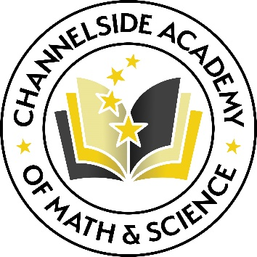

Mrs. Katie Lane

Third Grade

**OUTLINE**

(First and last name) received (degree, special training, study abroad) in (discipline or field) from (name of university) and is currently teaching (what grade and subject) at (name of school). A strong advocate for (list core professional beliefs or values), (she/he) involves (her/his) students in (list typical activities or projects that reflect core professional beliefs). (Her/His) professional interests focus on (list professional or research interests), and (her/his) current projects include (list professional activities and publications). In addition, she/he serves as (name of position) for (name of organization), and is a member of (name of advisory board or professional association). (She/he) was recently honored with the (name of award) for (her/his) contributions to (field, organization, etc.).

**SAMPLE**

Katie Lane received a B.A. in Elementary Education from University of Central Florida and is currently teaching third grade reading and language arts at Channelside Academy of Math and Science. A strong advocate of hands-on, inquiry-based learning, she involves her students in a variety of community service, problem-solving, and technology-infused activities that provide them with opportunities to use their strengths to help others. Her professional interests focus on communicative approaches to enhance learning through thematic planning, and cooperative learning and her current projects include the organization of a trip to Disney for the Reading Club to experience the park through the eyes of the “Kingdom Keepers”. In addition, she serves as the National Elementary Honor Society Sponsor for Channelside Academy of Math and Science, and is a member of the Florida Reading Association. She was recently honored with the Super Staff Award for her contributions to Channelside Academy’s STEAM Program.